Curriculum Vitae
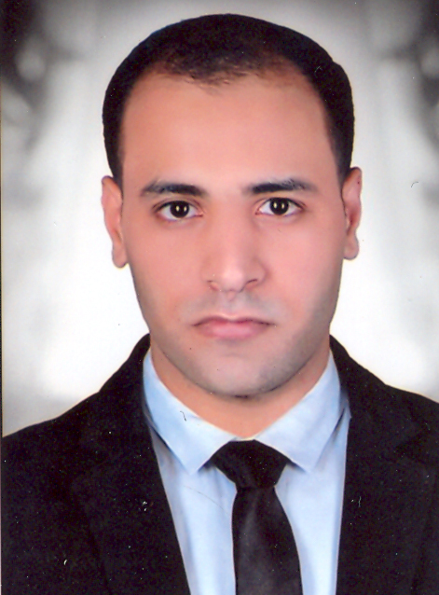
Name: Ahmed Abd-Elzaher Saady Mohammed
Date of Birth: October 1st, 1993
Gender: Male
Religion: Muslim
Nationality: Egyptian
Home Address: Sohag, Egypt
Contact Address: Department of Pharmaceutics, Faculty of Pharmacy, Assiut University
E-mail: ahmedabdelzaher317@gmail.com
Ahmedabdelzaher@pharm.aun.edu.eg
Languages: English (professional), Arabic (nativelanguage).
Academic Qualifications:
Bachelor in Pharmacy, Faculty of Pharmacy, Assiut University in 2017, and Demonstrator at Pharmaceutics Department, Faculty of Pharmacy, Assiut University.
Excellence with honor
Grade:
Demonstrator at Pharmaceutics Department Faculty of Pharmacy, Assiut University.
Computer Skills:
1- Microsoft Office Word.
2- PowerPoint.

